NOTICE

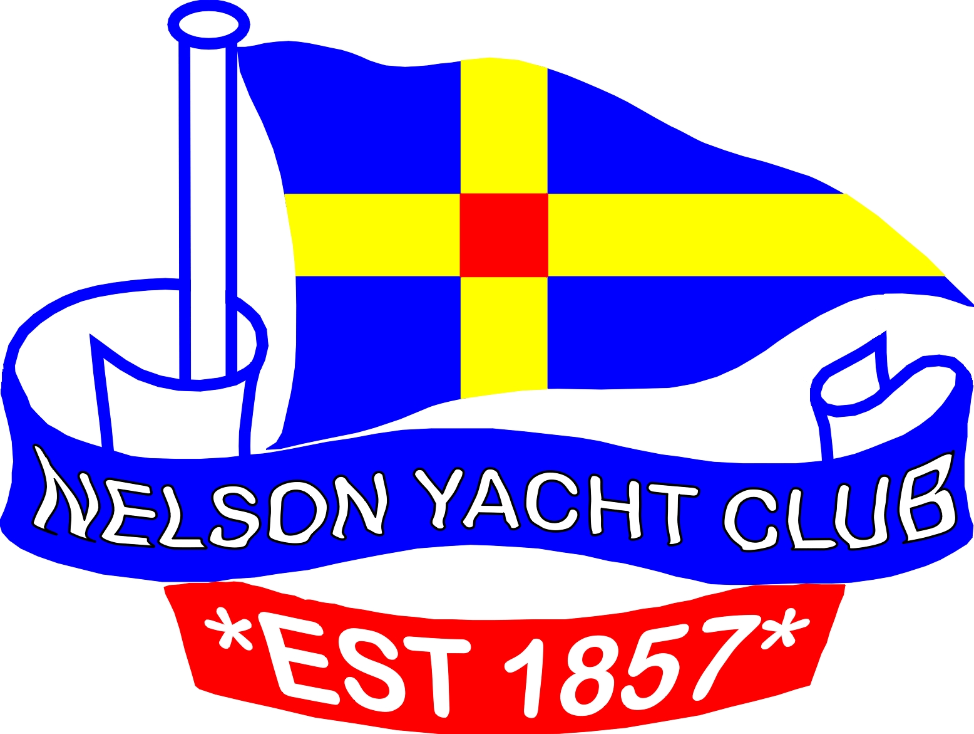

The Annual General Meeting for the Nelson Yacht Club is to be held on Sunday 27th July 2014 at 2.30pm in the Aurora Lounge.

Please put all nominations forward before then.

