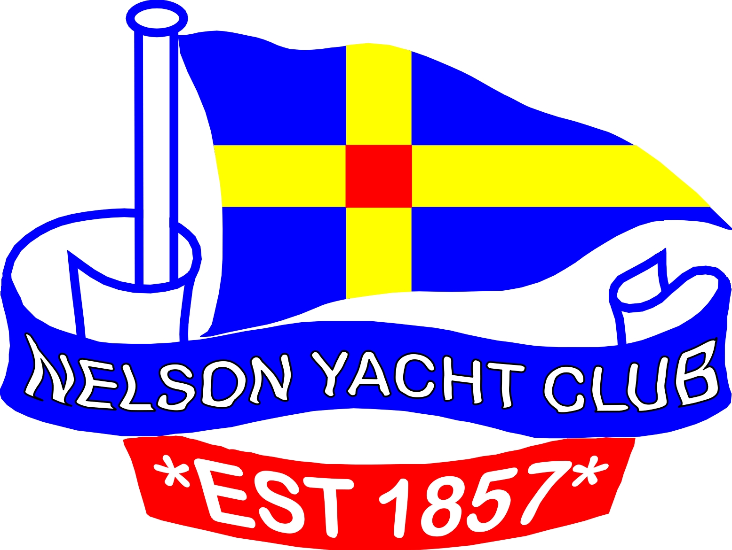
NELSON YACHT CLUB

AGM Nomination Form
2014/2015 Season

Nominations are sought for the following positions:

Administration Committee Other Sailing Committee
Commodore Patron Racing Secretary
Vice-Commodore Vice-Presidents Judge
Rear Commodore Auditor Slip Master
Boat Storage Master Honorary Solicitor
Secretary/Treasurer House Committee (3)
Administration Committee (4)

Nominations must be lodged no later than 48 hours prior to the Annual General Meeting
(2.30pm Sunday 27th July 2014)

I hereby nominate _____________________________________________________________ Full name (please print)

for the position of _________________________________________ for the 2014/2015 season

Proposed by _________________________________ ___________________________
Full name (please print) Signature

Seconded by ________________________________ ___________________________
Full name (please print) Signature

I accept the above nomination __________________________________________________
Signature of Nominee

Post: 322 Wakefield Quay, NELSON Email: nyc@xtra.co.nz Mail Box: Lower Lounge

For office use only

- Date and time nomination form received
- Membership status checked
- Added to register of nominations received

